|  |  |  |  |  |  |
| --- | --- | --- | --- | --- | --- |
| Date | 13-Dec-22 | | | Tester Name | Richard Belanger |
| Environment | Penfax - Test | | | Login used | TEST2 |
| Operating System | Windows | Version: | Update: | | |
| Software Used | Edge | Version: | Update: | | |
| Not Applicable | Version: | Update: | | |
| Release version | 22.4.1 | | | | |
| Title | M20.01 Process a Portability Transfer in | | | | |
| Test Type | Regression | | | | |
| Test Scenario | Perform a Portability Transfer for a Member | | | | |
|  |  | | | | |
| Expected Results | The transfer will complete and be seen in member’s account | | | | |
| Pass/Fail | Pass | | | JIRA# | N/A |

Describe your steps with screenshots:

Member’s Service before purchase

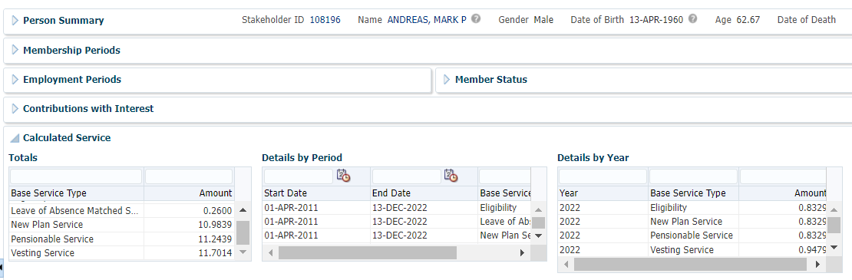

Member started April 1, 2011. Transferring service from January 1, 2011 to March 31, 2011

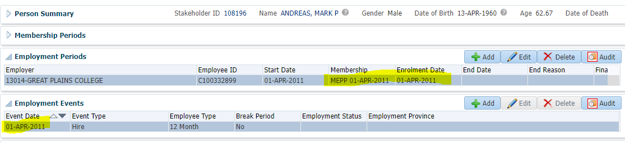

In Member Profile click Service Purchases

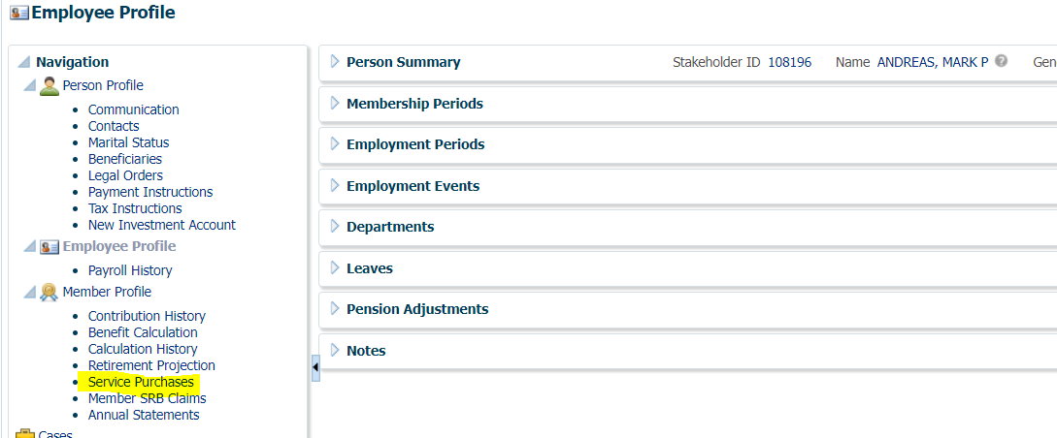

Click Add

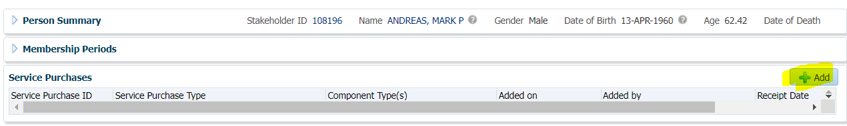

Choose Service Purchase Type; Service Purchase Status; Employer > Next

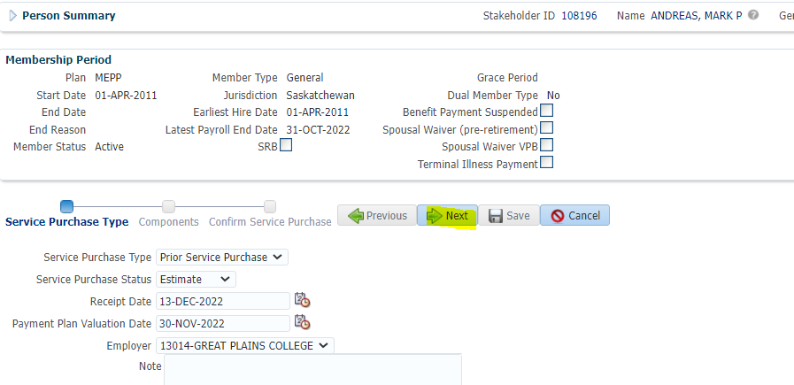

In Component Screen set Component Type = Purchased Service; Add Date Range of purchase; Click Populate Service Periods

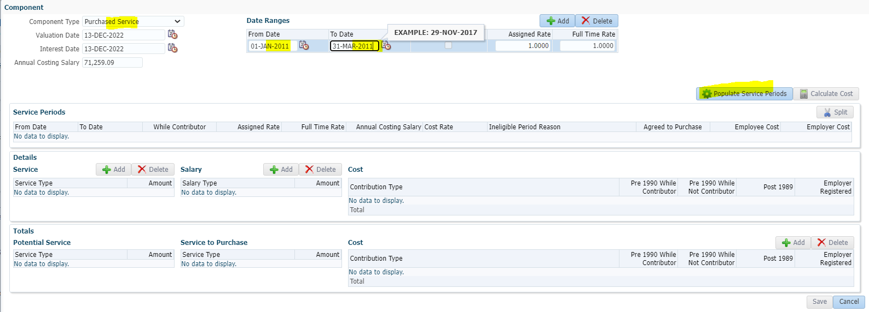

Click Calculate Cost

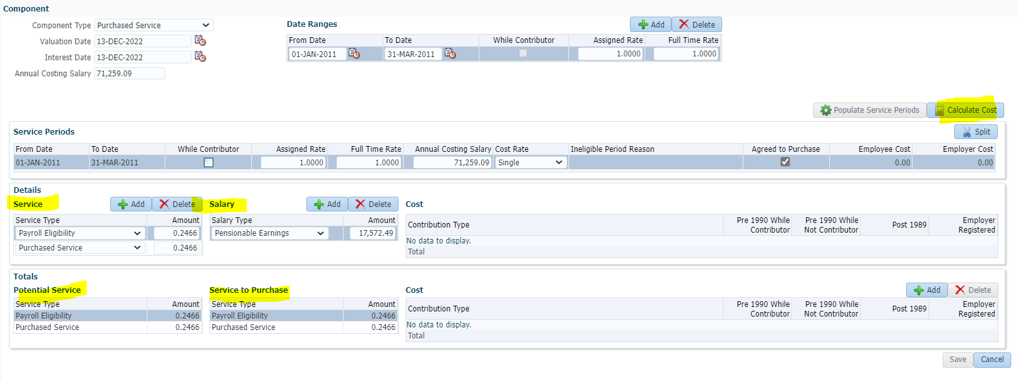

Save

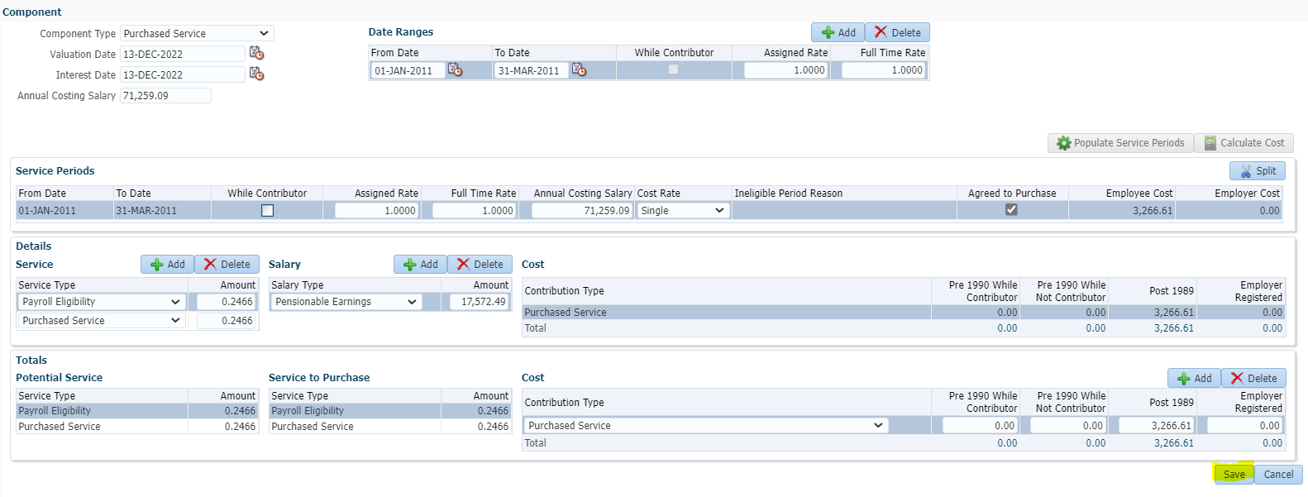

Next

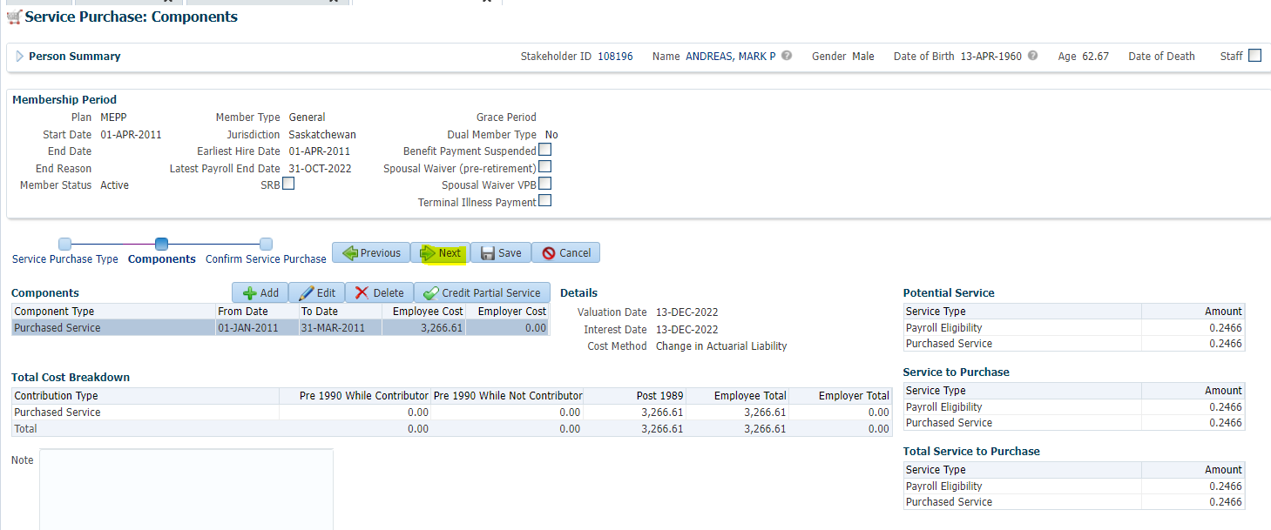

Save

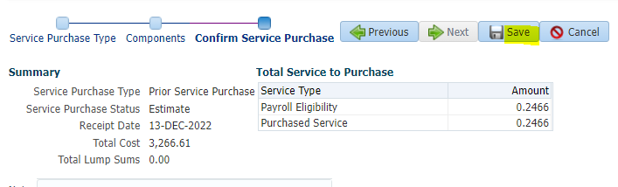

Click PSPA Tab

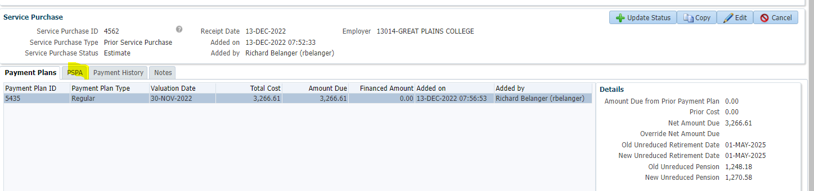

Click Add

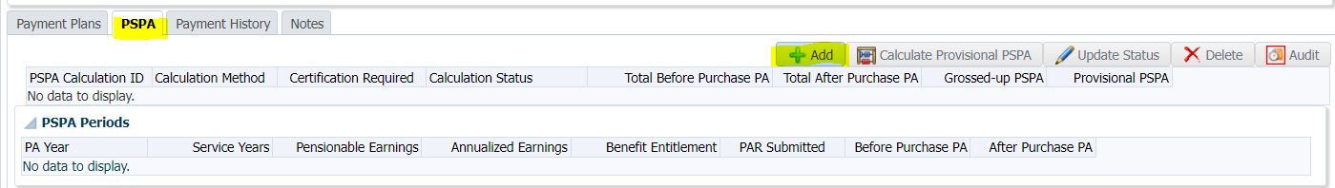

Calculation Method = Basic; Service Years and Pensionable Earnings are populated; Nothing to enter for before purchase PA>Save

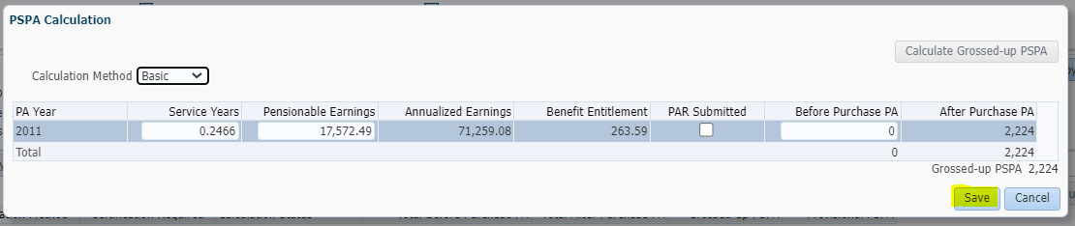

Click Payment Plans Tab; Click Update Status Button

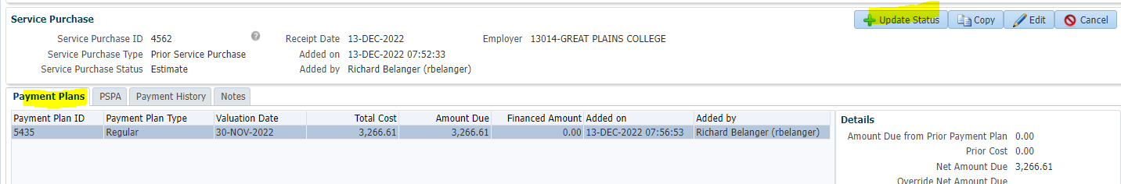

Set Status; Save

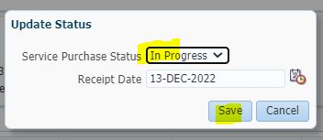

To Lump Sum Payments Tab>Click Add

